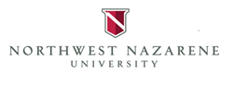
International Student On-Campus Employment Approval Form
The following student has been approved for on-campus employment. The student may work a maximum of 20 hours per week while school is in session. The student may work a maximum of 27 hours per week during established breaks (e.g. Christmas break and summer).

NNU ID Number __________________

Name ________________________________________________

J-1 Visa ☐
F-1 Visa ☐
Student is in good academic standing: Yes ☐ No ☐
Student is enrolled in a full course of study: Yes ☐ No ☐

Position approved: _____________________________________________________________________

Dates of approval: Beginning: _____________________________ Ending: ________________________

Signature of PDSO/DSO/RO/ARO: _____________________________________ Date: _______________

Date SEVIS Updated _____________________________ Initials _______________________

