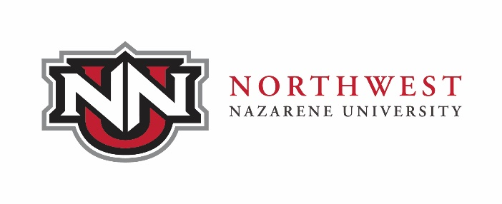
Letters of Verification

Types of verifications

1. Loan Deferments – Forms are provided by the lending institution to the student who must fill them out and give them to the verifications officer, who will then send them to whoever is designated.
2. Permanent Dividend Fund – Form provided by the State of Alaska.
3. Verification of Enrollment – Letter is created with dates to verify enrollment and sent to loan companies, insurance companies, scholarship donors, employers, and realtors for home buying purposes.
4. Verification of Degree – Letter shows that all work for the degree has been completed and the date the degree will be posted to the student’s records.

Information required for verifications:
Signed release from student
Name of student
Address and phone number
NNU Student ID number or Social Security number
To whom and where to send verifications
Term(s)/Semester(s) to be verified
Expected graduation date

Contact person:
Esther Read – Verifications Officer (208) 467-8433
Send inquiries to: Registrar’s Office
Northwest Nazarene University
623 S. University Boulevard
Nampa, ID 83686
E-mail: registrar@nnu.edu
Fax: (208) 467-8603

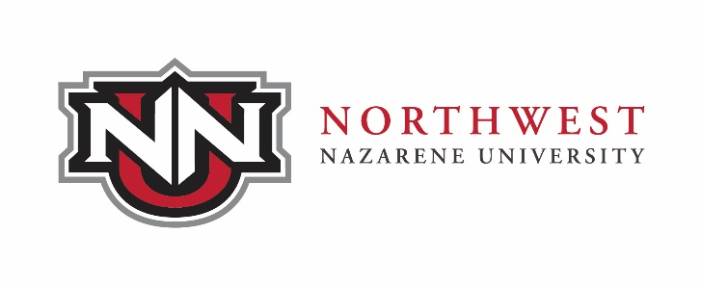

VERIFICATION OF ENROLLMENT

Student ID:____________________ Student SSN: ______________________

_______________________ ______________________ ___________________________
First Name Middle Name Last Name
_____________________________________
Address Presently Enrolled? □ YES □ NO _____________________________________
City, State, Zip
_____________________________________
Telephone

Enrollment verification is requested for the following semesters:

________________________________________

Verification letter is to be: □ Picked up □ Mailed □ Faxed

Please allow 48 hours for verification to be processed. □ E-Mailed

Send verification letter (s) to: (Please print clearly. Enter complete name and address.)

Name: _______________________ FAX/E-Mail : ________________________

Address: ______________________________________________________________

______________________________________________________________

Student’s Signature: _____________________________________ Date: ___________

www.nnu.edu/enrollverify

