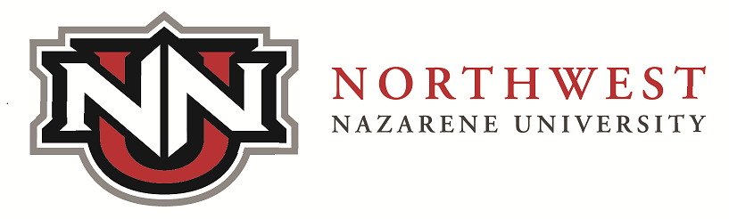

2025-2026 Graduate and Professional Application for Certification Completion
Please Note: A $25 application fee will be applied to your account.

Full Name
NNU ID #
NNU Email Address
Email you will use AFTER leaving NNU
Address to mail certificate to AFTER graduating: | Address:  City: State: Zip:  Country (if not US):
Cell number
(used for mailing notification info via text)
Certificate Applying for: (please choose one from each of the appropriate drop down menus):
Program/Department
Major
Completion Semester  (When do you plan to complete all certificate requirements?) | SUMMER 2025 (application due 1/15/2025)  FALL 2025 (application due 6/1/2025)  SPRING 2026 (application due 10/15/2025)  SUMMER 2026 (application due 1/15/2026)
Legal name to appear on your Certificate
PLEASE NOTE: Students completing a Certificate Program will not have their name printed in the NNU Commencement Program and will not be allowed to participate in NNU Commencement activities.

Signature |  | Date Signed

Outstanding Requirements
Please list all major requirements for graduation that are in-progress or not yet completed. Attach a separate sheet if more than ten items are outstanding.
 | Course # |  | Course Name |  |  |  | Semester | Credits
1
2
3
4
5
6
7
8
Program Approval: |  |  | Date

