
IMPORTANT: FOR A DEGREE TO BE CONFERRED, THIS FORM MUST BE COMPLETED AND SUBMITTED BY DATE INDICATED BELOW.

2025-2026 Graduate and Professional Application for Graduation
GRADUATION FEES will be applied to student account. Processing Fee ($25) is required for all students. Participation Fee ($100) for students participating in the Commencement Ceremony. This is non-refundable after April 1. Late Fee ($100) if application received after the deadline listed below*.

Full Name
NNU ID #
Email you will use AFTER leaving NNU
Address to mail diploma to AFTER graduating: | Address:  City: State: Zip:  Country (if not US):
Cell number (used for notification of diploma mailing info via text)
Major
Type of Degree
*Graduation Semester  (When do you plan to complete all graduation requirements?) | SUMMER 2025 (application due 1/15/2025)*  FALL 2025 (application due 6/1/2025)*  SPRING 2026 (application due 10/15/2025)*  SUMMER 2026 (application due 1/15/2026)*
Commencement Participation  Cap, gown, hood will be provided to Commencement participants. | Spring 2026  Spring 2027  NOT Participating in Commencement Ceremony (Name will appear in program)
Gown Size (refer to size chart below)
IF PARTICIPATING in Commencement Ceremony
Legal name to appear on your diploma and in the Commencement program
Tips for Pronouncing Your Diploma Name
Example: Mia = My-uh or Mia = Mee-uh
Hometown: City and State  If international, please include country | City State  Country
Military Status Definition: “38 U.S.C. 101(2) provides: The term ‘veteran’ means a person who served in the active military, naval, or air service, and who was discharged or released therefrom under conditions other than dishonorable.” | Active-Duty Military  Veteran  Does Not Apply
Are you a first-generation student?  (Neither parent or guardian earned a four-year college degree.) | Yes  No

Signature |  | Date Signed

Please note: If you have been cleared to participate in the Commencement Ceremony (met all requirements to participate), your name will appear in the Commencement program whether you walk in the ceremony or not. Once your name is in a commencement program you forfeit your opportunity to participate in any subsequent commencement. You may cancel your application to graduate up to three weeks prior to commencement by contacting your Program Coordinator.

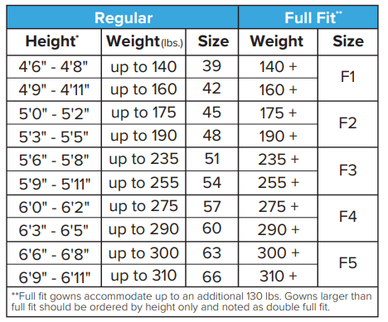

Outstanding Requirements
Please list all major requirements for graduation that are in-progress or not yet completed. Attach a separate sheet if more than ten items are outstanding.
 | Course # |  | Course Name |  |  |  | Semester | Credits
1
2
3
4
5
6
7
8
9
10
Program Approval:

